- A car travels 8 miles east and then 6 miles south. What is the total distance covered by the car?
14 miles
- Which of the following represents the slope of the position-time graph?
Velocity
- A man walks 0.5 miles from his home to the store. On his way home, he goes to the barbershop, which is 0.35 miles from the store. What is his net displacement after he reached the barbershop?
0.15 miles
4. The distance between home and the playground is 100 m. How much time does a dog take to reach home from the playground if running at a speed of 4 m/s?
- Seconds

5. A train travels south from station A to station B, with a speed of 70 km/hr, along a straight path in 1.5 hours. What is the displacement of the train when it travels from station A to station B?
105 km south
6. A truck starting from a farmhouse takes 2 hours to reach a factory 3 km away. What is the average speed of the truck?
1.5 km/hr
7. A bus travels 50 km south for 30 minutes and stops for 15 minutes. Then it travels 20 km for 15 minutes. What is the average velocity of the bus for its total trip?
70 km/hr
8. A ball is dropped from 5 m height. What is its acceleration when it is at a height of 2.5 m?
-9.8 m/s/s
9. A stone is thrown upward with an initial velocity of 6 m/s. What maximum height will the stone reach?
1.8 m
10. A ball is dropped from the top of a building 19.6 m high. What is the final velocity with which the ball hits the ground?
19.6 m/s
11. Which of the following is represented by the area under the velocity-time graph?
Displacement
12. The x and y components of a billiard ball's velocity are 5 m/s and 4 m/s respectively. What is the actual velocity of the billiard ball?
6.4 m/s
13. A car has an initial velocity of 11.2 m /sec. The car accelerates at 10.0 m /s2 for 8.0 seconds. What is the velocity of the car at the end of the 8.0 seconds?
91.2 m/sec
14. A boy throws a ball straight up in the air with an initial velocity of 15.0 m/ sec. Relative to the ground, what is the maximum height that the ball will reach?
11.5 m
15. A boy throws a ball straight up in the air with an initial velocity of 15.0 m/ sec. How long will it take the ball to reach its maximum height?
1.53 sec
16.
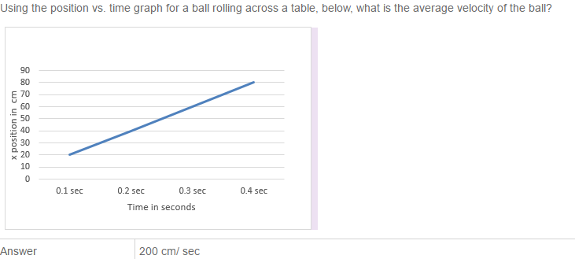

17.
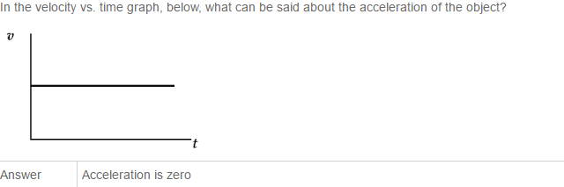
18. A car is traveling at 20 m/s. The driver applies the brakes, and the car slows with acceleration equal to -4.0 m/s/s. What is the stopping distance of the car?
50.0m
19. What is the acceleration of an object thrown vertically upward at an angle of 45º (wrt the horizontal) when the object reaches the top of the path?
-10 m/s/s downward
20. A stone is projected horizontally with a speed of 4 m/s from a bridge 6 m above the river. What is the distance from the bridge when the stone falls into the river?
4.4 m
21.
Consider what happens when you jump up in the air. Which of the following is the most accurate statement?
Answer | When you push down on the earth with a force greater than your weight, the earth will push back with the same magnitude force and thus propel you into the air.

22.
A man pushes against a rigid, immovable wall. Which of the following is the most accurate statement concerning this situation?
Answer | If the man pushes on the wall with a force of 200 N, we can be sure that the wall is pushing back with a force of exactly 200 N on hi

23.
A powerboat is heading eastward, upstream at 4 knots, in a river that has a current that flows at 1.5 knots at 35º north of east wrt the horizontal riverbank. What is the speed of the boat with respect to the ground?
Answer | 5.3 knots

24.
A bullet is fired at 45° with respect to horizontal with a velocity of 50 m/s. How long is the bullet in air?
Answer | 7.2 s

25.
A 2-kg object is fired from a cannon at a 30º angle wrt to the horizontal. The initial speed is 35 m/s. How high will the object travel?
Answer | 15.3 m

26.
A 2-kg object is fired from a cannon at a 30º angle wrt to the horizontal. The initial speed is 35 m/s. How far will the object travel down range?
Answer | 106 m

27.
A 2-kg object is fired from a cannon at a 30º angle wrt to the horizontal. The initial speed is 35 m/s. How long will the object be in the air before it lands?
Answer | 3.5 s

28.
A stone is projected horizontally at a speed of 6 m/s from the top of a 19.6 m building. Neglecting air resistance, how far (horizontally) from the edge of the building will the stone hit the ground?
Answer | 12 m

29.
What are the required properties of an inertial reference frame?
Answer | The reference frame must be at rest or moving at a constant velocity.

30.
A 2-kg box sits on a horizontal table. The force of friction between the box and the table is 10 N. The box is pushed to the right with an applied horizontal force of 5 N. What is the acceleration of the box?
Answer | Zero, the box will not move.

31.
A 2-kg box sits on a horizontal table. The force of friction between the box and the table is 10 N. The box is pushed to the right with an applied horizontal force of 20 N. What is the acceleration of the box?
Answer | 5 m/s/s right

32.
A 2-kg box sits on a horizontal table. The force of friction between the box and the table is 10 N. The box is pushed to the right with an applied horizontal force of 20 N. If the box starts from rest, how long will it take for the box to travel 10 m?
Answer | 2.0 s

33.
A 2-kg box sits on a horizontal table. The force of friction between the box and the table is 10 N. The box is pushed to the right with an applied horizontal force of 20 N. If the box starts from rest, how fast will the box be traveling after 3 s?
Answer | 15 m/s

34.
Sally Handygirl hits a nail squarely on the head with a 5-lb hammer. The nail is driven into a block of wood. What is the reaction force to the applied force?
Answer | The force of the nail on the hammer

35.
A 1,500-kg car is being towed at an angle of 20º wrt to the horizontal. A frictional force of 320 N opposes the motion. The car is experiencing constant velocity motion. What is the tension in the rope?
Answer | 340 N

36.
A golfer putts a 46-g ball with a speed of 3.0 m/s. Friction exerts a 0.020 N retarding force on the ball, slowing it down. Will the putt reach the hole, which is10 m away?
Answer | The putt makes it, but just barely with only a few cm to spare.

37. What is true of a Normal Force?
Normal force is always equal to weight
Normal force is always perpendicular to the surface of contact with the object
Normal force is always the same as the reaction force to the weight
Normal force is directly proportional to the frictional force
More than one of the above
38.
A 5-kg dog is sits on the floor of an elevator that is accelerating downward at 1.20 m/s/s. What is the magnitude of the normal force of the elevator floor on the dog?
Answer | 44 N

39.
While standing in a low tunnel, you raise your arms and push against the ceiling with a force of 100 N. Your mass is 70 kg. What force does the ceiling exert on you?
Answer | 100 N

40
While standing in a low tunnel, you raise your arms and push against the ceiling with a force of 100 N. Your mass is 70 kg. What force does the floor exert on you?
Answer | 800 N

41
3-kg puck slides due east on a horizontal frictionless surface at a constant speed of 4.5 m/s. Then, a force of magnitude 6.0 N, directed north, is applied for 1.5 seconds. What is the northward component of the puck's velocity after the force is applied?
Answer | 3.0 m/s

42
A 3-kg puck slides due east on a horizontal frictionless surface at a constant speed of 4.5 m/s. Then, a force of magnitude 6.0 N, directed north, is applied for 1.5 seconds. What is the speed of the puck after the force is applied?
Answer | 5.4 m/s

43
Jeremy has a mass of 60 kg. He is standing on a scale in an elevator that is accelerating downward at 1.7 m/s/s. What is the approximate reading on the scale?
Answer | 500 N

44
Certain SUV ads claim that their vehicles can climb a slope of 45º. What is the minimum coefficient of static friction between the tires and the road for this to be possible?
Answer | 1.0

45
A truck is traveling at 30 m/s on a slippery road. The driver slams on the brakes, and the truck start to skid. The coefficient of kinetic friction between the tires and the road is 0.20. How far will the truck skid before stopping?
Answer | 230 m

46
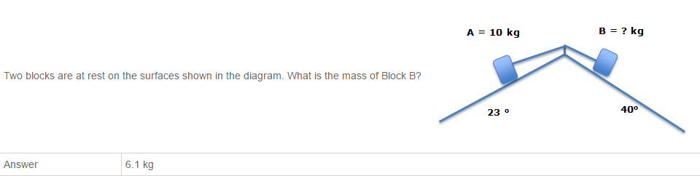

47
A ball on a string moves around a complete circle once a second. The tension in the string is measured to be 6.0 N. What would the tension in the string be if the ball went around in 0.5 seconds?
Answer | 24 N

48
Suppose the radius of the Earth doubled but its mass stayed the same. What would be the approximate new value for the free fall acceleration at the surface of the Earth?
Answer | 2.5 m/s/s

49
A 10 kg box sits on a frictionless inclined plane with an angle of incline of 42º. What is the magnitude of the acceleration of the box?
Answer | 6.7 m/s/s

50
A 10-kg box sits on a frictionless inclined plane that has an angle of incline of 42o. What is the magnitude of the normal force on the box?
Answer 74 N

51
A 500 g golf ball swings in a vertical circle at the end of a 1.5 m long string. When the ball is at the bottom of the circle, the tension in the string is 15 N. What is the speed of the ball at that point?
Answer 5.5 m/s
52
53
Planet Z is 10,000 km in diameter. The free-fall acceleration on planet Z is 8.0 m/s/s. What is the mass of planet Z?
Answer | 3.0 E 24 kg

54
Planet Z is 10,000 km in diameter. The free-fall acceleration on planet Z is 8.0 m/s/s. What is the free-fall acceleration (closest value) at 10,000 km above Planet Z's north pole?
Answer | 0.9 m/s/s

55
A 20-kg sphere is at the origin and a 10-kg sphere is at (x, y) = (20 cm, 0 cm). At what point or points could you place a small mass such that the net gravitational force on it due to the spheres is zero?
Answer | (12 cm, 0 cm)

56
A spacecraft orbits the moon in a very low, circular orbit, just a few hundred meters above the lunar surface. The moon has a diameter of 3,500 km, and the free-fall acceleration at the surface of the moon is 1.6 m/s/s. What is the direction of the net force on the spacecraft?
Answer | Toward the center of the moon

57
A spacecraft orbits the moon in a very low, circular orbit, just a few hundred meters above the lunar surface. The moon has a diameter of 3,500 km, and the free-fall acceleration at the surface of the moon is 1.6 m/s/s. How fast is the spacecraft moving (closest value)?
Answer | 1,700 m/s

58
A spacecraft orbits the moon in a very low, circular orbit, just a few hundred meters above the lunar surface. The moon has a diameter of 3,500 km, and the free-fall acceleration at the surface of the moon is 1.6 m/s/s. How much time does it take the spacecraft to complete one orbit (closest value)?
Answer | 110 min

